Apache Kafka is a distributed event streaming platform used for building real-time data pipelines and streaming applications. It is designed for high-throughput, fault-tolerant, and scalable messaging.

Core Concepts

1. Topic
- A category or stream where records are stored.
- Partitioning: Topics are divided into multiple partitions, enabling parallelism.
- Data is ordered within a partition, but there’s no guarantee of order across partitions.

2. Producers
- Producers are client applications that publish messages to Kafka topics.
- Producers can specify a key to determine the partition for a message.

3. Consumers
- Consumers subscribe to one or more topics and process messages.
- Consumer Groups:
  - Each group has multiple consumers.
  - Kafka ensures that each message is delivered to only one consumer within the group.

4. Broker
- A Kafka server that stores and serves messages.
- Multiple brokers form a Kafka cluster.

5. Partitions
- Each topic is split into partitions.
- Partitions provide scalability and parallel processing.
- Each partition has an offset, which is a unique ID for each message.

6. Replication
- Each partition has replicas for fault tolerance.
- Leader: Handles all reads and writes.
- Followers: Replicas that sync with the leader.

7. ZooKeeper
- Used by Kafka for managing cluster metadata, leader election, and configuration.

8. Offset
- A unique identifier for each message within a partition.
- Consumers use offsets to keep track of which messages have been processed.

Kafka Workflow
- Producer sends messages to a topic.
- The message is written to a specific partition (based on key, round-robin, or custom logic).
- Kafka brokers store the messages durably in partitions.
- Consumers fetch messages from partitions based on their offsets.
- ZooKeeper ensures the cluster's metadata consistency.

Key Features
- High Throughput:
  - Kafka handles millions of messages per second with low latency.
- Durability:
  - Messages are stored on disk and replicated across brokers.
- Scalability:
  - Kafka scales horizontally by adding brokers and partitions.

- Fault Tolerance:
  - Replication ensures that data remains available even if brokers fail.
- Decoupling:
  - Kafka acts as a buffer between producers and consumers, allowing asynchronous communication.

Kafka Streams
Kafka Streams is a stream processing library built on Apache Kafka. It is used for building applications and microservices that process data stored in Kafka topics in real-time.

1. Core Concepts of Kafka Streams
- Stream:
  - A continuous flow of records (similar to a topic).
- Stream Processing:
  - Consumes input streams, applies transformations, and produces output streams.
- KTable:
  - A table that represents the latest state of a keyed stream.
  - Useful for stateful transformations (e.g., aggregations).
- Topology:
  - A directed acyclic graph (DAG) of stream processing nodes.
- State Stores:
  - Used for maintaining local state during stateful operations.
  - Allows querying of the current state.

2. Kafka Streams Workflow
- Read data from one or more Kafka topics as input streams.
- Process the data (filter, transform, aggregate, etc.).
- Write the processed data to another Kafka topic or external systems.

3. Key Features of Kafka Streams
- Built-in Fault Tolerance:
  - Uses Kafka for message storage and offsets for recovery.
- Scalable:
  - Applications can scale by running multiple instances.
- Event-Driven:
  - Processes events as they arrive in real-time.
- Stateful and Stateless Operations:
  - Stateful: Aggregations, joins, etc.
  - Stateless: Filtering, mapping, etc.
- Interactive Queries:
  - Query state stores in real-time.

4. Example Kafka Streams Application
Java Code Example:
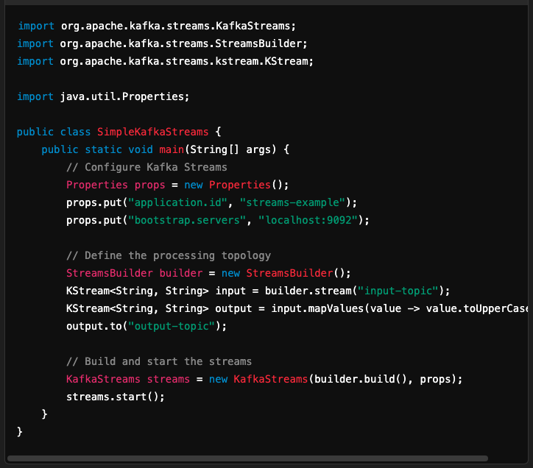

Comparison: Kafka vs Kafka Streams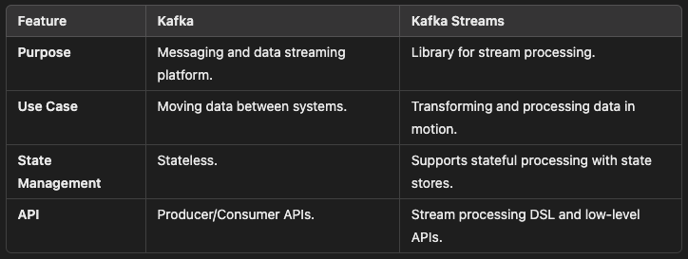

Kafka Streams vs Other Stream Processing Frameworks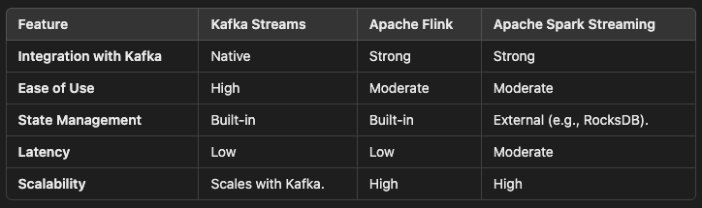

Summary
- Apache Kafka: A distributed messaging platform for streaming data between systems.
- Kafka Streams: A lightweight library for building real-time stream processing applications.
Both Kafka and Kafka Streams are essential for building scalable, event-driven architectures. Let me know if you'd like to dive deeper into any specific aspect!

